MINUTES OF FUNTINGTON PARISH COUNCIL MEETING
05 January 2022

PRESENT: Sheena King (SK)Chair Richard Littler (RL)
Kate Du Port (KDP) David Ash (DA)
Jean Simmonds (JS)

David Palmer (CDC) DP

MEMBERS OF THE PUBLIC: Two

AGENDA ITEM | NOTES/COMMENTS | ACTION | RESPONSIBILITY
1. Apologies | Pat Young, Bob Mousley, County Councillor Julian Joy (WSCC) | - None | N/A
2. Declaration of Interest | None declared | - None | N/A
3. Minutes of 01 December 2021 meeting | Minutes – Proposed, Seconded and AGREED | - Post on website | Clerk
4. Action Grid | Automated External Defibrillator (AED) Course  - To be advertised to gauge community interest:  - Poster  - Website  - Parish Magazine  - Course to be booked with agreed provider as soon as numbers of interested persons known.  Comms Strategy  - Meeting booked to create the new document in line with Business Plan, Email Policy, Comms Policy | - Create Poster  - Book Course  - Create Document | SK/Clerk  Clerk  SK/KDP
5. Public Questions | Is the proposed West Ashling noticeboard to replace the one on Heather Close?  No, after many discussions the proposed new noticeboard is to be located on Down Street. Once in place the no longer fit for purpose noticeboard on Heather Close will be removed. | - None | N/A
6. Receive Reports
Julian Joy (WSCC) | Pre-Christmas cancellation of meetings resulted in limited information to report:  - WSCC managed to get the principle of 20 miles an hour for country villages through the full council meeting as a motion and hope that this will enable wider use of this speed control along with the country lanes initiatives.  - The counties forward draft plan has just been issued by WSCC for comment and I’m hoping to review the headings for our next meeting. | - None | N/A
David Palmer CDC | There have been two significant events since the December meeting:  - Dec. 7: Special Council, Southern Gateway.  - Henry Booty Developments has advised CDC that it is withdrawing from the Southern Gateway Project. Reasons cited are the effects of Covid and the non-availability of the Lawcourts site.  - Plan is to go ahead with moving the bus station as a first rather tentative step forward.  - Negotiations for the Post Office site and for the single dwelling at 45 Basin Road are stalled at present.  - A long debate in Council pointed to broad and continued support for a new southern entrance to the City and for continued negotiations with both the Post Office and 45 Basin Road.  - Regular reports on progress are to be made to the Economic Development Committee on which I sit.  Discussion at meeting:  - DP stated that an error was made in the Planning of the Southern Gateway as land/building owners were not approached before the plan was created. Compulsory purchase is an option but still under discussion.  - He continued that the intention is to have an aesthetically pleasing welcome to Chichester and that this is still achievable.  - The bus garage negotiation is still to be completed and the finished project is unlikely to be achieved until after the next District Council Elections in 2023.  - DP answered a question regarding the future of the railway crossings and the impact this decision has on the movement of traffic. He stated that the issue is more about addressing the parking and traffic in general which had not been properly discussed to date and the issue of parking is a complex one due to the revenue it generates.  - Local Plan and Land Supply:  - Chichester District Council believes that it can show the relevant authorities that it has a five-year housing land supply.  - This may well turn out to be a significant advance in the slow road towards delivering a new Local Plan.  - More important in the short term it should strengthen CDC’s hand in opposing housing Development on inappropriate sites, particularly in the Raughmere appeal case brought by Berkeley Homes.  Discussion at meeting:  - DP stated that if the 5-year housing land supply has now been agreed, progressing with the Local Plan is looking more hopeful.  - He reiterated the importance of the Raughmere appeal case. | - None | N/A
7. WA Playground
- Trees | Quote Update  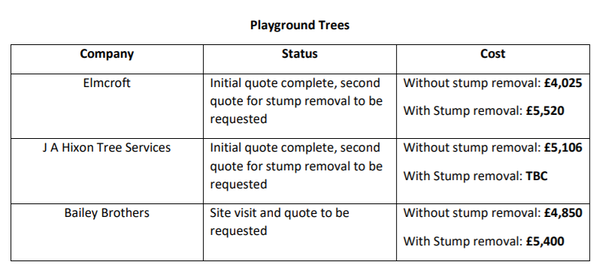  - It was agreed that the trees including stumps would be removed. This led to further discussion regarding the existing ‘stump chair’ which currently sits between the two trees. It was agreed that a quote should be obtained for the removal of this also.  - The quotes were discussed although the second quote had not been received from JA Hixon. Based on the first quote it was felt that it was impossible for this to be competitive.  - Two remaining quotes discussed and although similar in price, Elmcroft was favoured as the Council had worked with them previously.  - Elmcroft Proposed, Seconded and AGREED by unanimous vote. | - Obtain Quote  - Award Contract | Clerk  Clerk
- Equipment Update | - SK stated that two quotes had now been received and a third site visit was carried out by Playsafe Playgrounds at the beginning of December.  - Once all quotes have been received a decision will be made on how best to proceed.  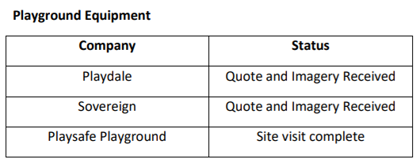 | - Add to February Agenda | Clerk
8. Pony Paddock | - The Clerk summarised the status of a Land Registry (LR) application regarding the boundary of the PC owned pony paddock.  - In July an application to LR had been made to update the boundary of the pony paddock based on drawings submitted by a surveyor.  - Unfortunately the application had been returned by LR stating that ‘the plan accompanying the application is insufficient for use in determining a boundary’  - The Clerk had therefore contacted the surveyors who replied that they had only been asked to submit and charged for a straightforward survey which they subsequently overlayed. However the amount of research etc required to answer the questions raised by LR would usually be dealt with by a solicitor and would cost considerably more.  - It was unclear what the exact purpose and necessity of the LR application was and therefore decided that further research would be needed in order for the Council to make an informed decision. | - Report on what was applied for and add to February Agenda | RL
9. Queen’s Jubilee | - KDP asked the question as to whether the PC wishes to organise any events / commemorations for the Queen’s Jubilee weekend 02-05 June 2022.  - Potential ideas:  - Lighting a beacon  - Planting a tree  - Wildflower verge  - Street / Community Party  - Discussion regarding the difficulties faced by the PC due to the 4 villages that make up the Parish and the challenges faced when organising one central event.  - Discussion regarding how the PC could consult and gauge public opinion and what questions should be asked.  - It was agreed that instead of organising an event the PC would ask the community if planned celebrations could benefit from PC support with advertising and obtaining funding. | - Create poster / advert | SK / Clerk
10. Defibrillator re-location | - JS summarised the issues surrounding the current location of the Automated External Defibrillator (AED) at the Horse and Groom, East Ashling.  - The location was originally chosen due to the building’s listed status. However the status of the outbuildings is unclear.  - The licensee keeps the front door unlocked so that the defibrillator can be accessed when the pub is closed. However this complicates the pub’s insurance policy.  - The defibrillator is not easily accessed as it is located behind the front door which means that the door has to be opened and then closed before the defibrillator can be moved for utilisation.  - It was agreed that although planning permission had been refused in the past, CDC should be contacted to request a reconsideration of permission to move the AED to the garage wall where it could be monitored by CCTV. | - Write to CDC | JS
11. Noticeboard | Three noticeboard options circulated prior to the meeting:  - Noticeboard Company £1,075.00 ex VAT  16 x A4 Post Mounted Double Door Board  - Signs Display Shop £852.00 ex VAT  12 x A4 Post Mount Noticeboard  - KBS Depot £1211.00 ex-VAT  18 x A4 notices  - After a brief discussion the KBS noticeboard was the favoured choice due to the sensible idea of raising doors suspended on gas struts for easy opening and support.  - KBS Noticeboard in green Proposed, Seconded and AGREED  - It was also agreed that a Funtington Parish Council header would be added to the noticeboard. | - Place order Once Installation Quote Finalised | Clerk
- Installation Quote | - BM had been sent all the location information requested. However due to his absence from the meeting and no previously submitted quotation the matter could not be discussed.  - It was confirmed that the noticeboard would not be ordered until an installation quote had been accepted. | - Add to February Agenda | Clerk
12. Annual Parish Assembly Speaker | - Although not mandatory there is the possibility for the Council to invite a speaker to address and inform the audience on community matters at the Annual Parish Assembly which is to be held in April.  - The Clerk reminded the Councillors that this is separate to a Parish Council meeting and is a relatively informal event for the community and asked for suggestions for a speaker.  - Following on from the fantastic presentation by South Downs National Park (SDNP) Planning Officer Hannah Collier as part of the Neighbourhood Plan consultation process, it was suggested that an SDNP speaker be invited to talk about the establishment of wildlife corridors.  - Venue for Assembly to be discussed further | - Contact SDNP | Clerk
13. Planning | Applications/Decisions - CDC and SDNP  - Planning meeting to be held on Monday 10 January 2022 by Zoom.  - Very few Applications and Decisions received over the Christmas period.  - There were no controversial applications for discussion. | - Publicise minutes when complete | Clerk
14. Neighbourhood Plan (NP) | - BM who was to speak about the NP was absent from meeting. Therefore, no update was submitted.  - No Steering Group Meetings had been held since the December Full Council Meeting. | - Add to February Agenda | Clerk
15. Finance
- Consider and Approve Monthly Cashbook | Cash book presented - already circulated to FPC members.  Payments already made  - The precepted 2021-22 charity donations had now been paid.  - Minor essential works carried out to the phone kiosk paid.  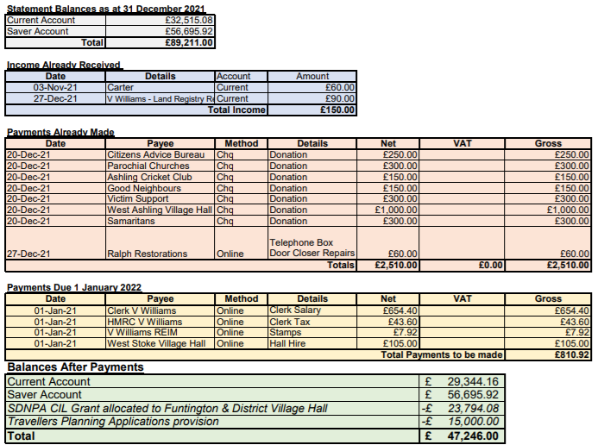  Approved | - Make Payments | Clerk
- Precept | - The Clerk summarised that following the December 2021 Finance Committee Meeting, a provisional precept had been set.  - The committee held extensive discussions to ensure that necessary money was applied for whilst keeping any increase in the precept to a minimum.  - Proposed Precept for 2022-23: £24,557.20  - This is an increase of 1.4% (£337.20)  - There was discussion on any queried items:  - Defibrillator increase – to cover the cost of all new pads and potential battery changes.  - Fingerpost Increase – to cover the cost of necessary repairs to a couple of posts. It was felt that ongoing maintenance should be carried out to prevent them falling into extreme and costly disrepair as had happened previously.  - Precept Proposed, Seconded and AGREED | - Submit Precept Request | Clerk
16. Parish Notices | - SK reported that following an enquiry to Westbourne Parish Council about newsletter distribution she had asked the Clerk to recontact Dor-2-Dor who deliver for the equally rural Parish.  - Dor-2-Dor acknowledged that they had previously turned down the opportunity as Funtington is under the minimum order quantity in addition to being a largely rural area. However they have now submitted a quote for £275+VAT.  - As this was received after the publication of the agenda a decision would be made at the next meeting as to when the next newsletter should be distributed. | - Add Newsletter to February Agenda | Clerk
17. Date of next meeting | - Wednesday 02 February 2022 Time 6:00 pm at West Stoke Village Hall | - Post agenda on website and noticeboards | Clerk
Meeting Closed | Meeting closed at 19.20 | None | N/A
Signed................................................................. Chairman
All reports are available in full on the website: https://www.funtingtonpc.org

